Computer Networks 1
Lab 7
HTTP with Wireshark

Name:

Student no.: ……………………………..

I. Objectives
In this Lab exercise, we will explore some aspects of HTTP protocol by using Wireshark:
- HTTP GET and Response
- HTTP message format
- HTTP Conditional GET and Response
- Get HTML files with embedded objects
II. Content
- HTTP GET and Response
Practice with HTPT protocol by downloading a simple HTTP file without any embedded objects. Follow these steps:
- Open a Web browser
- Open Wireshark as in the previous exercise, enter http in Filter text field to display only HTTP messages
- Start capturing packets with Wireshark
- Enter http://cse.hcmut.edu.vn into browser
- Stop capturing with Wireshark
The resulted window will be similar to Figure 1. This figure shows that there are two HTTP messages captured by Wireshark: GET message and the response from the web server. Details of these messages are shown in packet content window. Note that the HTTP message is carried in a TCP segment. This segment is carried in a IP packet, and then in an Ethernet frame. Therefore, Wireshark display Frame, Ethernet, IP and TCP.
Investigate the contents of HTTP GET and response, and answer the following questions:
- HTTP version used by the browser and web server?
- Which languages can the browser accept?
- IP addresses of your computer and the web server?
- Status codes sent from the server to the browser?
- When was the retrieved HTML file last modified?
- How many bytes of content were returned to the browser?
- By examining the raw data in content window, do you notice any header together with data that are not displayed in the packet window? List a few headers if there are.

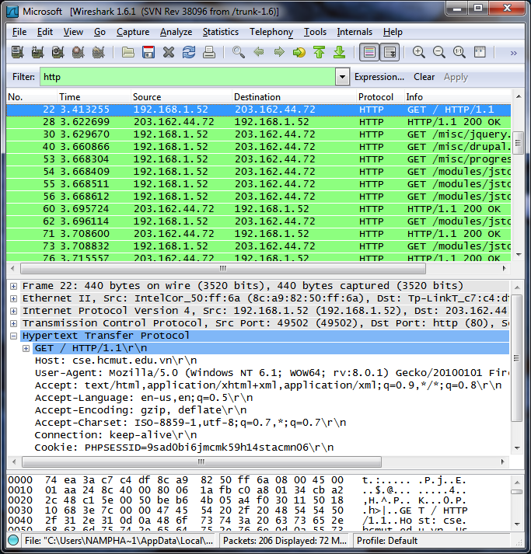
Figure 1: Wireshark window after entering http://cse.hcmut.edu.vn
- HTTP Conditional GET
Most of the browsers today use cache to speed up browsing process. Therefore, Conditional GET is used to get an HTTP object. Make sure that the cache of your browser is cleared before continuing with the following steps:
- Open the browser
- Start Wireshark
- Enter http://cse.hcmut.edu.vn to the browser
- Click refresh to update content of the web page http://cse.hcmut.edu.vn
- Stop Wireshark
- Enter http in the filter textbox. Your Wireshark window will look like Figure 2.

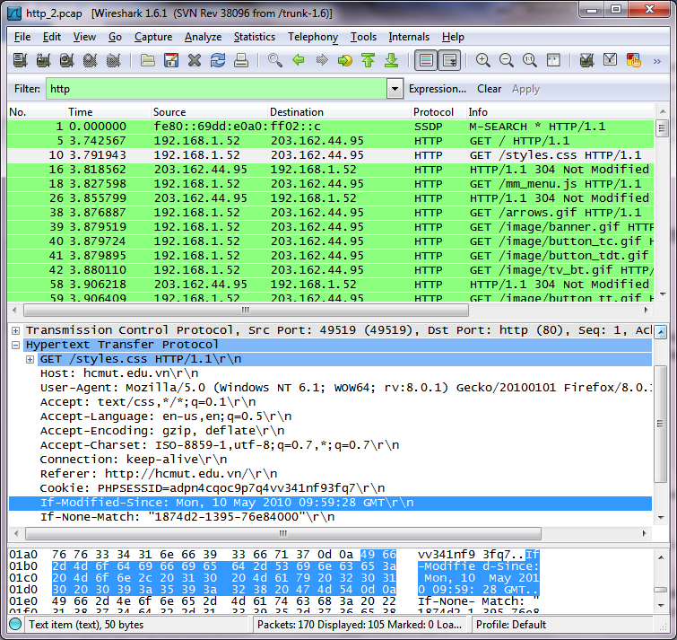
Figure 2: Wireshark window when browsing http://cse.hcmut.edu.vn second time.
Answer the following questions:
- Examine the content of HTTP GET message from the browser. Do you see “IF-MODIFIED-SINCE” in HTTP GET line?
- Examine the responses from the server. Did the server reply exactly the content of the file? How do you know that?
- Examine he content of the second HTTP GET message. Do you see “IF-MODIFIED-SINCE” in HTTP GET line? If so, what do you see after “IF-MODIFIED-SINCE”?
- What are the HTTP status codes and associated messages that the server used to respond to the second HTTP GET? Did the server respond with the who file content? Explain your answer.

